Lab 1 Setup ECEN 299 Library and Project

Table of Contents

Setup ECEN299 Library 1

Extract ECEN299 Library Files 1

Open Altium Designer and Get License 1

Open ECEN299_Library.LibPkg 2

View Components in the SCH Library. 3

View Footprints in the PCB Library 3

Create Integrated Library from the Library Package 4

View Components in the ECEN299_Library.IntLib 5

Create a PCB Project 5

Add Schematic Sheet 6

Add a PCB Layout Document 6

Select File > Save All.Create a Zipped archive of the project files 7

# Setup ECEN299 Library

## Extract ECEN299 Library Files

1. Download ECEN299.zip from I-Learn to your Desktop.
2. Extract ECEN299.zip on your Desktop (i.e., %UserProfile%\Desktop).

When complete, the folder ECEN299_Library should be located at the path shown and contain the following files:

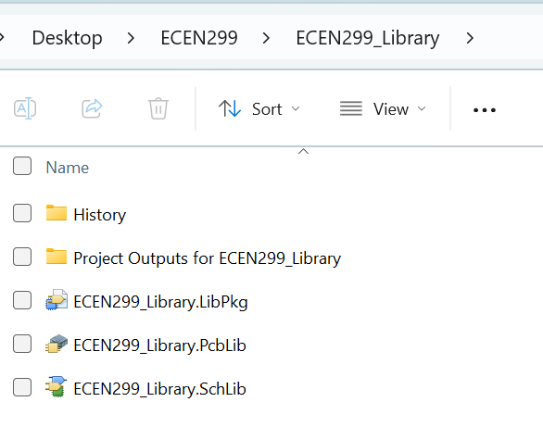

## Open Altium Designer and Use Your Student License

1. Select Windows Open > Altium Designer.
2. Sign In.
3. Select Current User Information > Licenses > Use License.

1. Close Licenses window.
   1. Right click on the license management tab and select close license management.
2. Close workspace if opened.

## Open ECEN299_Library.LibPkg

1. Select File > Open Project.
2. Select Browse in the lower left corner.
3. Browse to %UserProfile%\Desktop\ECEN299\ECEN299_Library.
4. Select ECEN299_Library.LibPkg.
5. Click Open.
6. If you don’t see a list of projects on the left panel, open View > Panels > Select Projects .
7. Right click ECEN299_Library.LibPkg.
8. Select Add Existing to Project.
9. Select All Files as the file type.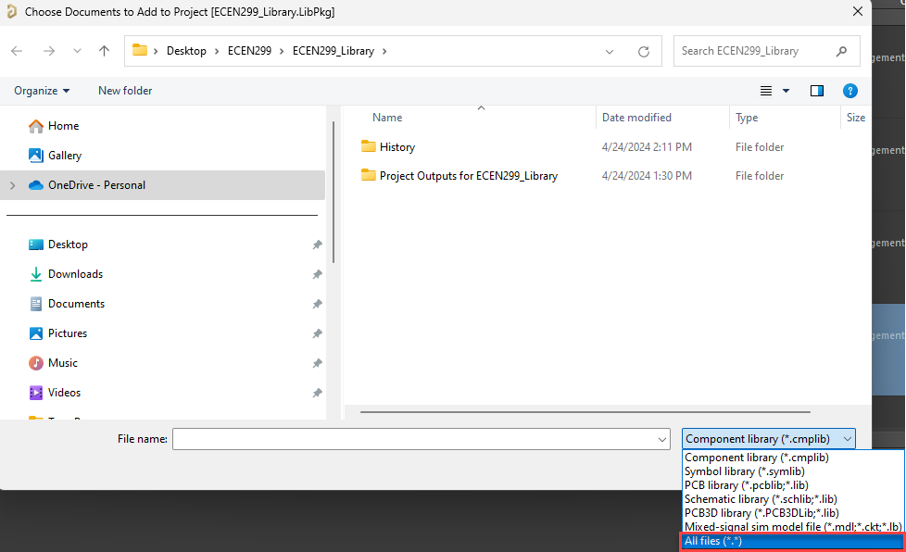
10. Select ECEN299_Library.SchLib and ECEN299_Library.PcbLib.
11. Select Open.
12. Right click ECEN299_Library.LibPkg.
13. Select Save.

### View Components in the SCH Library.

1. If the project panel has closed: Select View > Panels > Projects.
2. Double click ECEN299_Library_Schematic.SchLib to open it.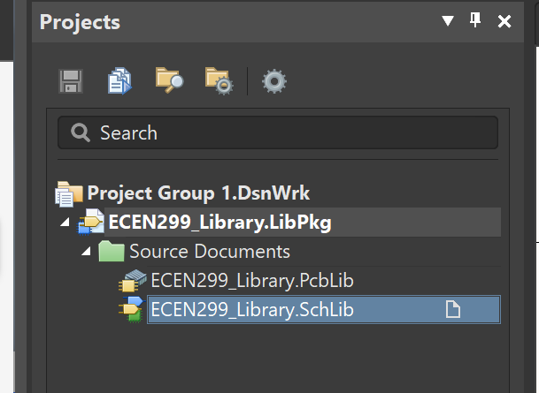
3. Select View > Panels > SCH Library.

This allows you to see what components are in the SCH Library as shown.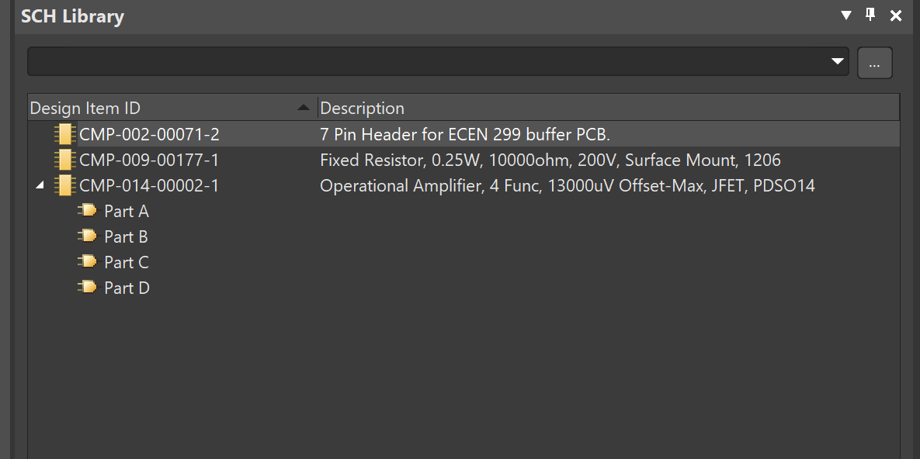

### View Footprints in the PCB Library

1. Open View > Panels > Projects.
2. Select ECEN299_Library_PCB.PcbLib.
3. Select View > Panels > PCB Library.

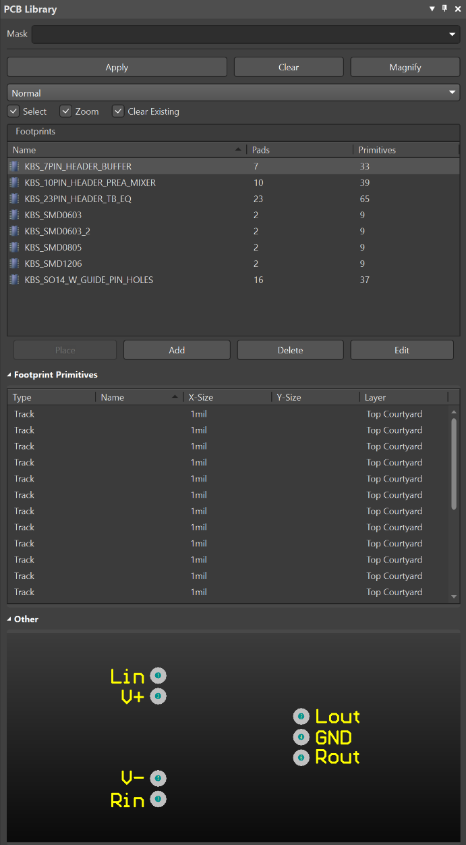

## Create Integrated Library from the Library Package

1. Open View > Panels > Projects.
2. Right click ECEN299_Library.LibPkg.
3. Select Compile Integrated Library ECEN299_Library.LibPkg.

This creates and places ECEN299_Library.LibPkg in the subdirectory “Project Outputs for ECEN299_Library” in the folder .\Desktop\ECEN299\ECEN299_Library.

This also installs the library. The path to installed libraries can be seen at View > Panels > Components >tripple bar button shown below > Libraries Preferences > Installed.

## View Components in the ECEN299_Library.IntLib

1. Select View > Panels > **Components**.
2. Select **ECEN299_Library.IntLib** in the pulldown menu.

The components can be placed on a schematic from here.

# Create a PCB Project

1. Select File > New > **Project**.
2. Enter fields as followsA screenshot of a computer program

   Description automatically generated
3. Select **Create**.

This creates a folder named ‘Lab1_Buffer’ and a file in it named ‘Lab1_Buffer.PrjPcb.’

## Add Schematic Sheet

1. Right click on **Lab1_Buffer.PrjPcb**.
2. Select **Add New to Project > Schematic** document. *(If SCH list shows up you can drag it to the side of the screen or park it to the side of the main window.)*
3. Right click on **Sheet1.SchDoc**.
4. Select **Save**.

The default directory is the project directory: Desktop\ECEN299\Lab1_Buffer.

1. Enter File name: **Buffer_Sheet1.SchDoc**.
2. Select **Save**.

## Add a PCB Layout Document

1. Right click on **Lab1_Biffer.PrjPcb**.
2. Select **Add New to Project > PCB** .

PCB1.PcbDoc is created.

1. Right click on **PCB1.PcbDoc**.
2. Select **Save**.

The default directory is the project directory: Desktop\ECEN299\Lab1_Buffer.

1. Enter File name: **Buffer_PCB1.PcbDoc**.
2. Select **Save**.

## Select File > Save All. Then create a Zipped archive of the project files

1. Right-click on the project file (Lab1_Buffer.PrjPcb) and select Project Packager (or select Project tab > Project Packager).
2. Select Next, Next, Next, and Finish to accept the defaults.
3. Right-click on the project and select Explore to see the zip file just created.
4. 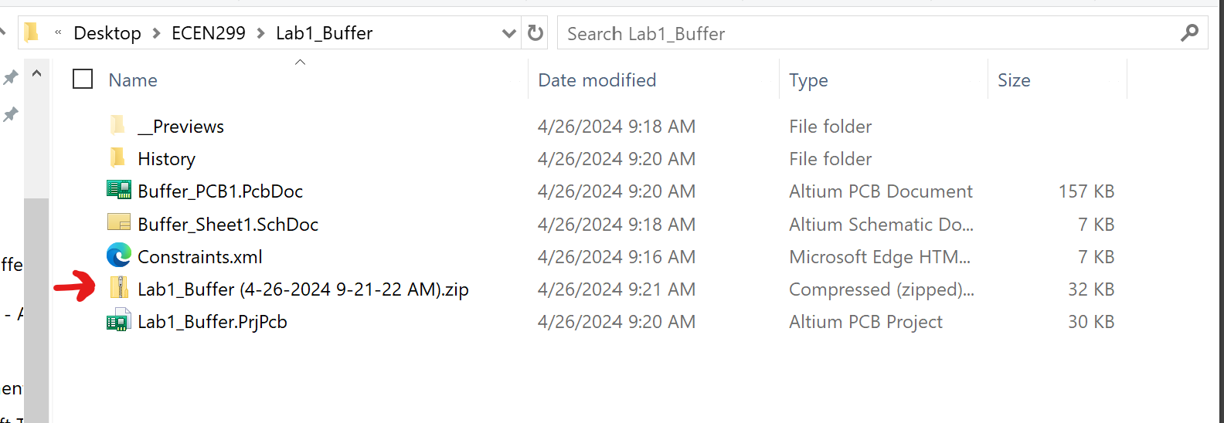
5. Upload this zip file to I-Learn.